Experiment 4.1
Discrete -Time System
Aim:
To analyze the behavior of a discrete-time linear system using a difference equation. The Aim is to understand how the input sequence is transformed by the system, represented by a difference equation, and to observe the output sequence.
Program:
% Discrete-Time System
clc;
clear;
close all;
% Input sequence
n = 0:10;
x = [1 2 3 4 5 6 7 8 9 10 11];
% Discrete-Time System
y = filter([1 1],1,x);
% Display output
disp('Output Sequence:');
disp(y);
% Plotting
figure;
subplot(2,1,1);
stem(n,x,'filled');
grid on;
title('Input Sequence x(n)');
xlabel('n');
ylabel('Amplitude');
subplot(2,1,2);
stem(n,y,'filled');
grid on;
title('Output Sequence y(n)=x(n)+x(n-1)');
xlabel('n');
ylabel('Amplitude');
Output Waveform:
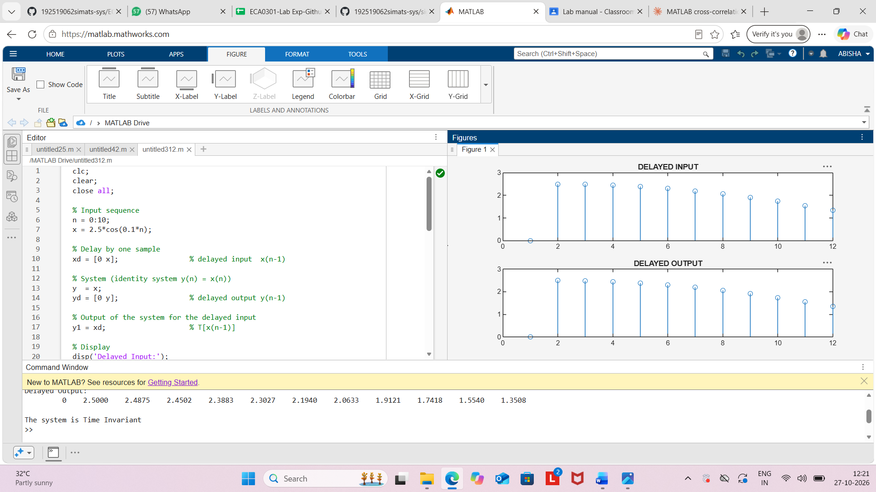

Result:
The discrete-time system y(n)=x(n)+x(n−1) was implemented using MATLAB. The output
sequence was obtained by combining the present and previous input samples, and the input
and output signals were displayed using stem plots.

